February 24th, 2008
Hi

I am writing a bit earlier than expected as I got up at 8:30 am after looking at the clock and thinking it was 9:30 am. The cold weather warning in HK was lifted the other day after 24 continuous days of cold weather; this is compared with the record of 27 days (though later the Observatory said that this year set the record so I am not actually sure). (Cold weather, I think, means days when the temperature falls below 12⁰C.)
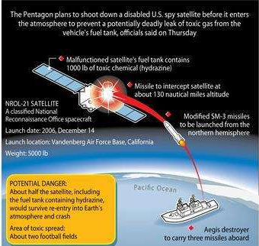
On Tuesday, Lydia (‘Fei Fei’) Shum died, aged only 62. Do you remember her? She died of cancers of the kidney and gall bladder and also suffered from diabetes and high blood pressure, all undoubtedly linked to her weight. She is to be buried in Vancouver where she has family.
The US military missile intercepted and destroyed an ailing satellite, which they said contained toxic fuel and to prevent it from causing harm on re-entry - or so they say! I am sure it was also a very good excuse to test their ‘star wars’ system. Still, it was quite an impressive feat. Saw on the TV news about the B-2 bomber that crashed on take-off in Guam – the first crash since its launch in 1988.
Yesterday’s run ended a week of difficult aerobic exercise. In the gym, for some reason, the 10-minute skips and 30-minute runs were so difficult. For some of the skips I actually had to stop and have a rest while the runs were done very slowly. The run yesterday was from CU station up to Ma On Shan and back. There had been rain and as the stony paths were very slippery, so I was warned on the way up. On the way down the inevitable spill happened when I slipped and injured my leg, but still kept on going. At 3 hours 10 minutes (allowing 1 minute for the spill), it was one minute slower than last year and 16 minutes slower than my best three years ago. The outward route included two steep hills, which I found difficult; for the final ‘assault’ up Ma On Shan, I even took off my ‘Camelbak’ water pack and hid it behind a bush, hoping that the lesser weight would help – I don’t think it did. The slip occurred close to the spot where I tripped and had the massive crash two years ago.
A lot of Rugby this weekend. In the Six Nations matches, Wales had their third win out of three games and England beat France. More Super-14 games too. The Crusaders had a big win against last year’s champions, the Bulls, in SA, winning 54-19 after being down 12-0 after 30 minutes.
That’s about it for this time.

Cheers.

